Assignment 3
Docker/Kubernetes

Q.1. Create a directory by name myapp. Go to the directory. Create a simple java program by name calc.java which will take 2 numbers from the user and display the result of addition and multiplication. Create a file by name Dockerfile. Type following in the file.

FROM ubuntu
RUN apt update -y
RUN apt install default-jre -y
RUN mkdir /myapp
WORKDIR /myapp
COPY calc.java /myapp/
RUN javac calc.java
CMD [ “/bin/java” , “calc” ]

Save the file.
Now create image of your application by using following command.
docker build -t myapp . # Don’t forget dot at the end.

Once the process finishes. Check if the image is created using command - docker images.
Now run the container using your image.

docker run --rm -ti myapp

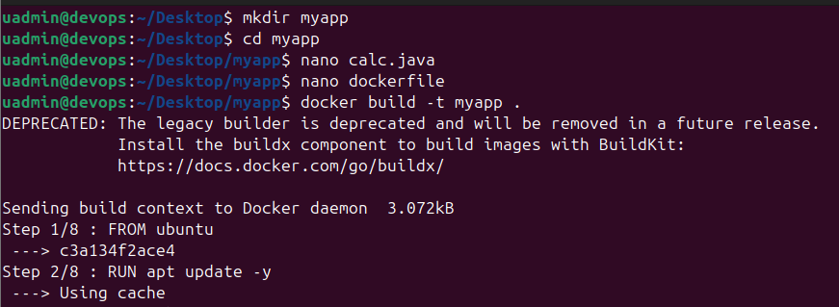
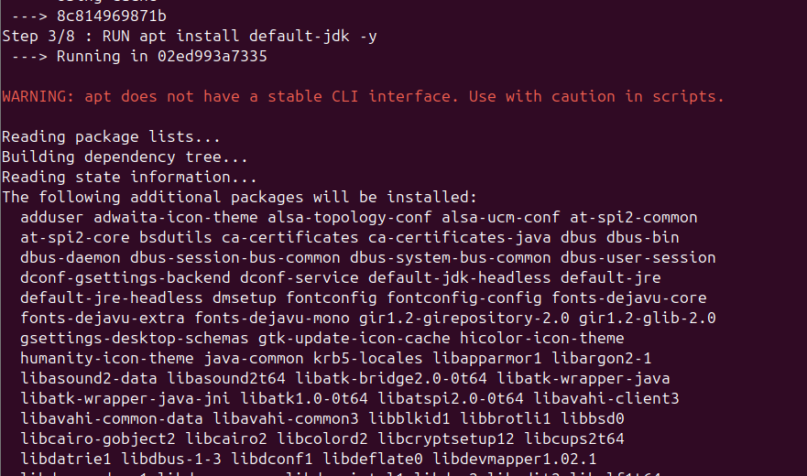
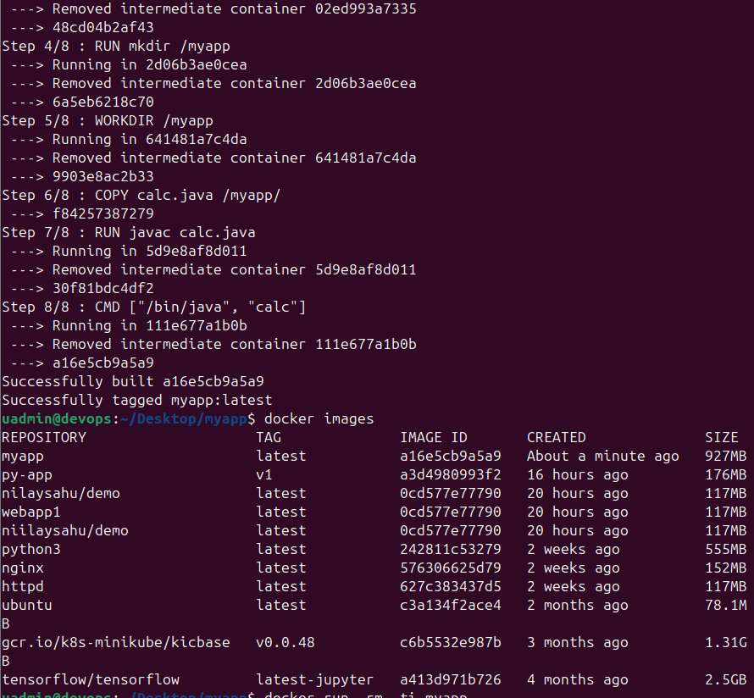
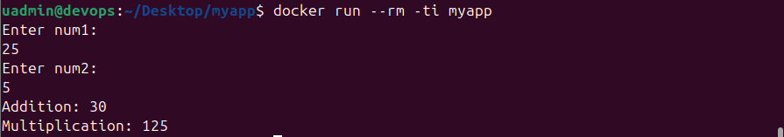

Q.2. Install minikube. Create a deployment by name web1 using nginx image. Create a service for this deployment. Scale the deployment to 4 replicas - kubectl scale deployment web1 --replicas=4. Check with the command - kubectl get pods. Now reduce the replicas to 1 - kubectl scale deployment web1 --replicas=1.

Q.3. Create a directory. Go to that directory. Create your index.html file that will display your name and PRN number. Create a dockerfile as in question1. Add following to the file.

FROM httpd
COPY index.html /usr/local/apache2/htdocs/

Save the file. Use docker build command to build your application image.
docker build -t webapp1 . # Don’t forget dot at the end.

Now run the container using above image and verify.

docker run --name web3 -p 8000:80 -d webapp1

Now go to the browser and check by typing http://localhost:8000

Stop and delete the container.

Create a repository on the Docker Hub. Upload this docker image to this docker hub repository.

Now create a deployment on Minikube using this image with 2 replicas. Create a service of type NodePort. Find the service URL. Check if your application is available.

